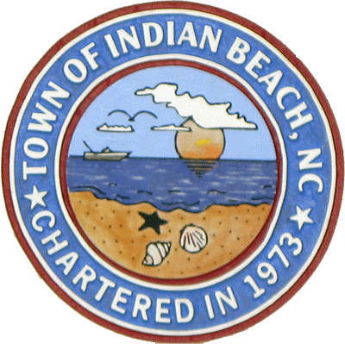(252) 247-3344
(252) 247-0513 fax
1400 Salter Path Rd
Indian Beach, NC 28512
Stewart Pickett, Mayor
Elizabeth (Dale) Williford,
 Mayor Pro Tem
 
Commissioners
Joel Fortune
Pete Wylie
Michael Luther

 
 


The

**REGULAR TOWN BOARD MEETING MINUTES**

**NOVEMBER 17, 2020**

The meeting was called to order at 5:00 p.m. by Mayor Pickett. Commissioner’s Fortune, Wylie and Luther attended meeting. Commissioner Williford was absent. Also attending were Town Manager White, Deputy Clerk Brickhouse, Police Chief Pollock, Fire Chief Haraway, Public

Works Director, and news media.

**2**. Commissioner Fortune gave the invocation, and all joined in the Pledge of Allegiance.

**3.** Commissioner Wylie made a motion to approve the minutes of September 9, 2020 Regular Meeting. Commissioner Luther seconded the motion. The motion passed unanimously.

**4. FINANCE OFFICER/TOWN MANAGER**

Town Manager White reported that a Public Hearing has been posted per FEMA requirements to receive requested reimbursements. The public had thirty (30) days to make comments. He has not received any comments.

The town received $20,000 as part of the County allocation from the CARES Act. Manager White will be using the funds to offset personnel cost in both Police and Fire Departments. The Sea Isle Plantation North Homeowner’s Association made a $2,000 donation to both the Police Department and Fire Department.

Police Chief Pollock, Fire Chief and Manager White met with the County Emergency Management to discuss the radio communication issues. They are working on some solutions to correct their issues. Chief Pollock stated that PKS is having issues also.

Manager White attended a meeting with the Beach Commission and the Army Corp of Engineers on November 4, 2020. The purpose of the meeting was to get a better understanding of what the Corps has to offer with regards to the town’s beach re-nourishment program.

Manager White said that he would be attending on November 16th to discuss and vote.

On November 5th he sent out another RDP for audit services to six (6) firms approved by the LGC. He wants to have a contract for approval at the February meeting.

Property taxes collected for the month of September was $ 153,937.78 and for October $94,005.44.

Manager White said the meeting for October was cancelled because of covid-19.

The following are reports included in the agenda.

1. Cash Balance Report
2. Budget vs. Actual report by department
3. Manual Journal Entries
4. Bank Reconciliations for September and October.

Manager White announced that the Planning Retreat would be February 15, 2021 at 9:00 and lunch will be provided.

**5. POLICE DEPARTMENT REPORT** – Chief Pollock gave his report for September and October and it was accepted as presented.

**6. FIRE DEPARTMENT REPORT** – Chief Haraway gave his report for September and October and it was accepted as presented.

**7. PUBLIC WORKS REPORT** – Director Golden gave his report and it was accepted as presented.

**9. NEW BUSINESS**

(a) Manager White asked for a motion to approve First Bank’s proposal and authorize the town manager to sign all documents related to the loan. Manager White had contacted three (3) banks and First Bank was selected. The funds are to replace cascade system and turn out gear washer.

(b) (1) Manager White asked for a motion to record $20,000 received from the County as part of the CARES act. The funds will be used to offset salaries in the Police and Fire Departments. Commissioner Luther made the motion. Commissioner Fortune seconded the motion. The motion passed unanimously.

(2) Manager White asked for a motion to add a $2,000 donation from Sea Isle HOA to the General Fund. One thousand will be added to Police Vehicle Maintenance and $1,000 to the Fire Department Fire Equipment. Commissioner Fortune made the motion to approve the budget amendment. Commissioner Wylie seconded the motion. The motion pass unanimously.

Commissioner’s comments, public comments.

The meeting adjourned 5:19.

__________________________ _________________________

Linda T. Brickhouse, Deputy Clerk Stewart M. Pickett, Mayor